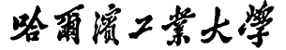

（威海）

Report of Software Architecture

Homework 4.3-2: Command Pattern

Basic information
Team name： _______________________________

Class number: ____________________________________________________
Department/school：
Team members with student numbers：

_______________________

Instructor’s comments and score
comments：

score：
signature of the instructor：

Year month date

Homework descriptions：
See the diagram below for a example 11.3 designed by using the Command pattern. Run the source code before you do anything.
<<interface>>
Command
execute (JPanel panel)
ListenerInvoker
actionPerformed(ActionEvent e)
<<creates>>
<<uses>>
GFan
+startRotate()
+stopRotate()
<<uses>>
<<creates>>
GWindow
+open()
+close()
FanOnBtn
execute()
FanOffBtn
execute()
WindowOpenBtn
execute()
WindowCloseBtn
execute()
ActionListener
ClientUI
<<uses>>
<<uses>>
Homework requirement: Below is the graphical user interface by running the program. In the figure below, add two buttons named “Aircondition On” and “Air Condition Off”.
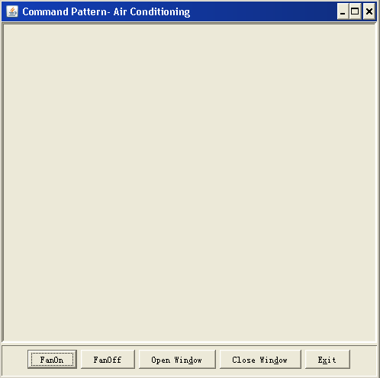

You also need to add a class named AirconditionOnBtn and a class

AirconditionOffBtn. If a user click the “Aircondition On” button, then
the upper part of the GUI shoud become blue and if a user click the “Air

Condition Off” button, the upper part of the GUI shoud become pink.

Note: You need to add another class named GAirConditioner into this
design, in which the above mentioned “blue” and “pink” functionalities
should be implemented. You need to write code for all the newly added
classes mentioned above.

- Draw your new class diagram here

- Describe your new design, including
    - What classes have been added to the existing class hierarchy?
    - The relationship between the existing classes and the newly added classes.

- If a user clicks on the button “Aircondition On”, what methods in what classes have been invoked. List them in correct order.

- Typical input and output from running your program

